# Weblogic Remote EJB Injection bugy

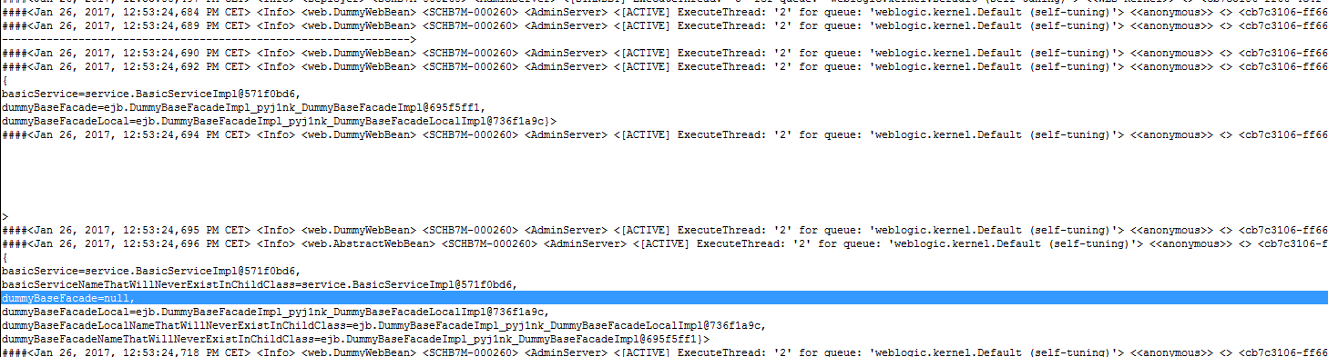

We can see that the following Injection point is null:

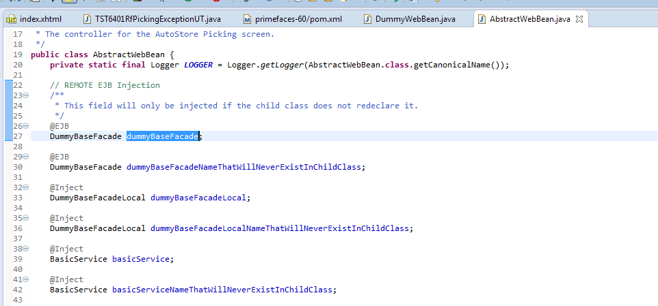

All other injection points are properly filled in, probably because the @EJBs are resolved by weblogic and the @Injects are resolved by WELD.

# Instructions

## Deploy the application

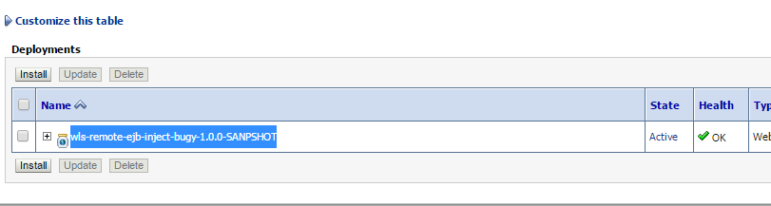

## Visit the index page and click the button

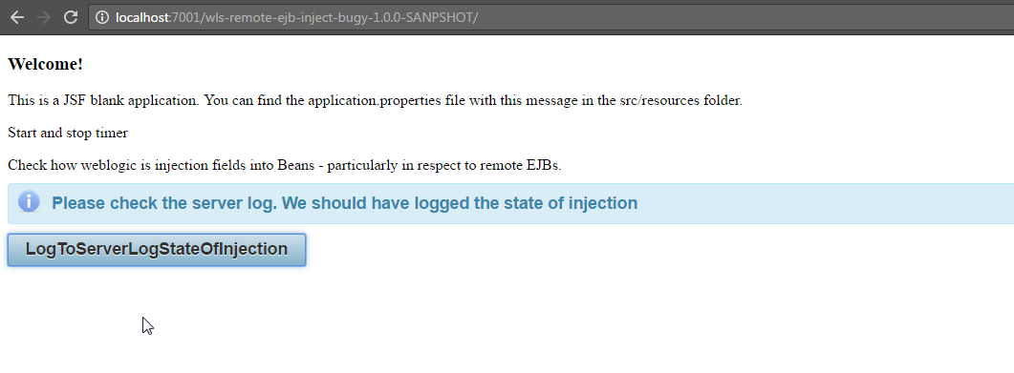

## Check the log file

